AWS Task-2
Task Description:

Set up a VPC with an Internet gateway, create a public subnet with 256 IP addresses, a private subnet with 256 IP addresses, make a route table connecting the Internet gateway and the subnets, and launch a Linux EC2 instance by using the above VPC and public subnet.

created a public & Private subnet with 256 IP addresses.

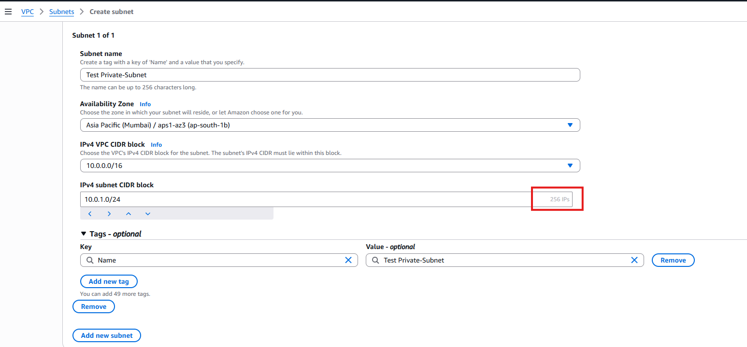
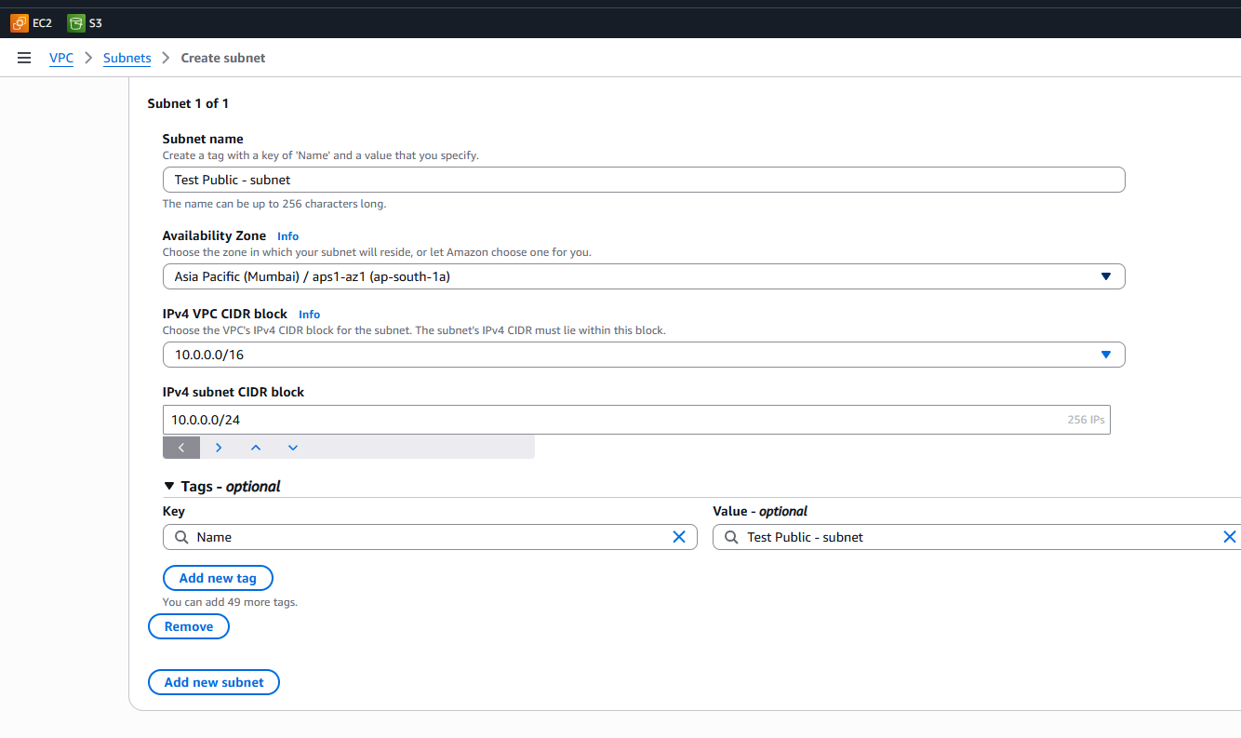
Linux EC2 instance by using the VPC and public subnet:
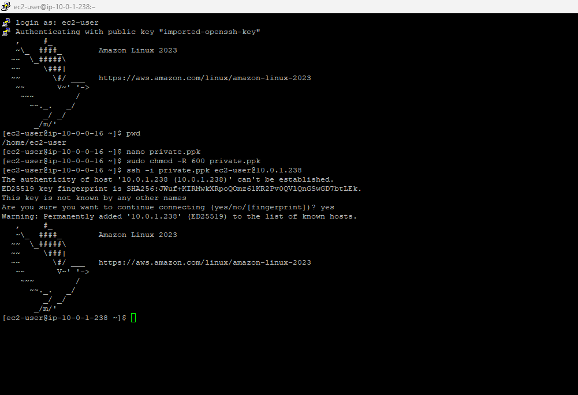
Accessing Nat gateway through public machine:
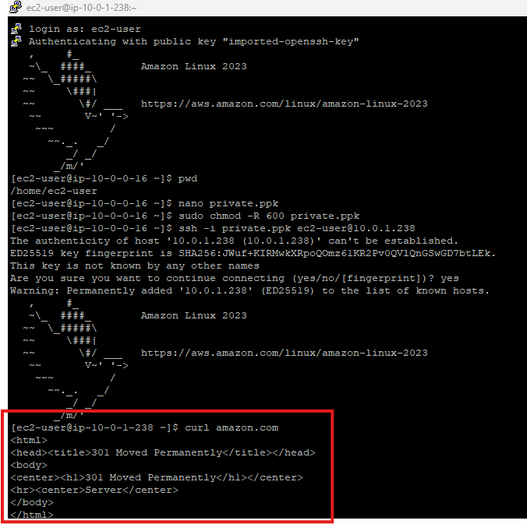
After Removing Nat gateway:
